# NN Assignment Report

Taimoor Aslam 04071713016 BS-CS 7th

## Dataset Description

**Title: Gender Recognition by voice**

Gender Recognition by Voice and Speech Analysis

This database was created to identify a voice as male or female, based upon acoustic properties of the voice and speech. The dataset consists of 3,168 recorded voice samples, collected from male and female speakers. The voice samples are pre-processed by acoustic analysis in R using the seewave and tuneR packages, with an analyzed frequency range of 0hz-280hz (human vocal range).

The following acoustic properties of each voice are measured and included within the CSV:

* **meanfreq**: mean frequency (in kHz)
* **sd**: standard deviation of frequency
* **median**: median frequency (in kHz)
* **Q25**: first quantile (in kHz)
* **Q75**: third quantile (in kHz)
* **IQR**: interquantile range (in kHz)
* **skew**: skewness (see note in specprop description)
* **kurt**: kurtosis (see note in specprop description)
* **sp.ent**: spectral entropy
* **sfm**: spectral flatness
* **mode**: mode frequency
* **centroid**: frequency centroid (see specprop)
* **peakf**: peak frequency (frequency with highest energy)
* **meanfun**: average of fundamental frequency measured across acoustic signal
* **minfun**: minimum fundamental frequency measured across acoustic signal
* **maxfun**: maximum fundamental frequency measured across acoustic signal
* **meandom**: average of dominant frequency measured across acoustic signal
* **mindom**: minimum of dominant frequency measured across acoustic signal
* **maxdom**: maximum of dominant frequency measured across acoustic signal
* **dfrange**: range of dominant frequency measured across acoustic signal
* **modindx**: modulation index. Calculated as the accumulated absolute difference between adjacent measurements of fundamental frequencies divided by the frequency range
* **label**: male or female

## **Explanation of work done**

I used this dataset to train my model based on whether a voice is of male or female using attributes of the voice which are mentioned above. My dataset contains 3,168 records and I divided my dataset into training set and test set with ratios 80 and 20 respectively. I used two approaches named sequential model(Logistic Regression) and two layer model ( Multi-layer Network) to train my model to predict which has greater accuracy rate. The learning rate values I used are 1.0, 0.5,0.01,0.001,0.001,0.0001 and epochs for each learning rate are 1000. In two layer network I used combinations of sigmoid, relu and tanh activation functions in hidden layer and output layer and the results are as follows.

## **Analysis**

1. **Sequential Model**

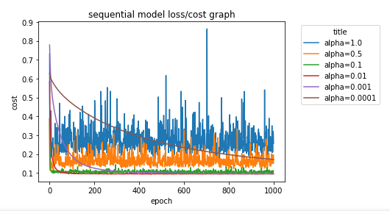

**Fig.1**

In fig.1 we can see that at learning rate 0.001 and 0.01 gives the same minimum cost. So, in my opinion it is the best option than other learning rate values as it consistently decreases as the number of epochs increases.

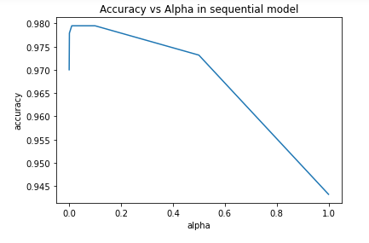

**Fig.2**

In fig.2 we can see that learning rate 0.001 gives the best accuracy than others. So, in my opinion it is the best option than other learning rate values as it gives highest accuracy value.

1. **Two Layer Network with activation functions ( hidden layer: sigmoid, output layer: sigmoid)**

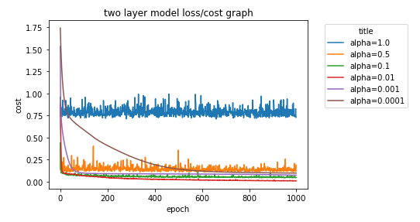

**Fig.3**

In fig.3 we can see that at learning rate 0.01 the cost is minimum. So, in my opinion it is the best option than other learning rate values as it consistently decreases as the number of epochs increases.

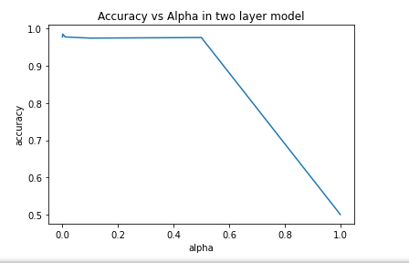

**Fig.4**

In fig.2 we can see that learning rate 0.0001 gives the best accuracy than others. So, in my opinion it is the best option than other learning rate values as it gives highest accuracy value.

1. **Two Layer Network with activation functions ( hidden layer: relu, output layer: relu)**

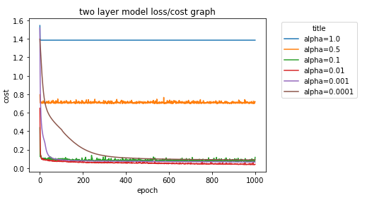

**Fig.5**

In fig.5 we can see that at learning rate 0.01 the cost is minimum. So, in my opinion it is the best option than other learning rate values as it consistently decreases as the number of epochs increases.

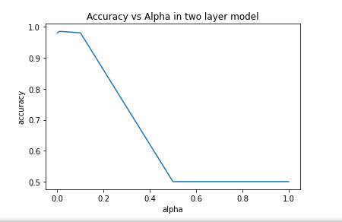

**Fig.6**

In fig.6 we can see that learning rate 0.0001 gives the best accuracy than others. So, in my opinion it is the best option than other learning rate values as it gives highest accuracy value.

1. **Two Layer Network with activation functions ( hidden layer: tanh, output layer: sigmoid)**

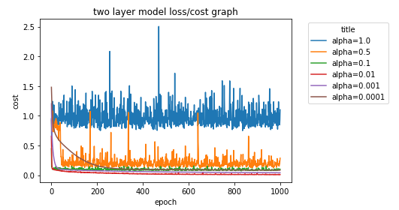

**Fig.7**

In fig.7 we can see that at learning rate 0.01 the cost is minimum. So, in my opinion it is the best option than other learning rate values as it consistently decreases as the number of epochs increases.

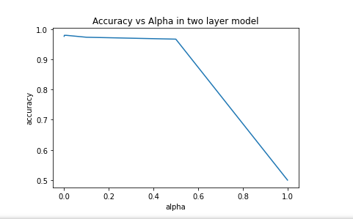

**Fig.8**

In fig.8 we can see that learning rate 0.0001 gives the best accuracy than others. So, in my opinion it is the best option than other learning rate values as it gives highest accuracy value.

1. **Two Layer Network with activation functions ( hidden layer: relu, output layer: sigmoid)**

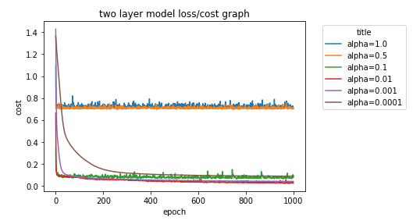

**Fig.9**

In fig.9 we can see that at learning rate 0.01 and 0.001 gives the minimum cost. So, in my opinion it is the best option than other learning rate values as it consistently decreases as the number of epochs increases.

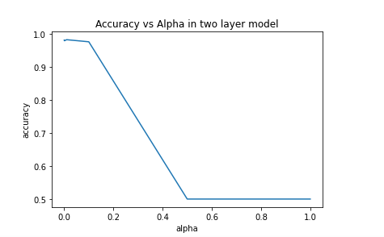

**Fig.10**

In fig.10 we can see that learning rate 0.001 gives the best accuracy than others. So, in my opinion it is the best option than other learning rate values as it gives highest accuracy value.

## Conclusion

We used sequential and two-layer model to train our model and analyzed above. So, the conclusion is that both the models gives same accuracy rate and cost per epoch for the given learning rates. We can use any of the above models to train our model to get best accuracy and low cost as per required.